**Construct an E-R diagram for a car-insurance company whose customers own one or more cars each. Customers are identified by their ID, name and address. Each car has its won license no, model and year of purchase. A car is associated with zero to any number of recorded accidents. Every accident has its report no, place of accident and date of accident recorded with it. Amount damaged is also noted after every accident.**

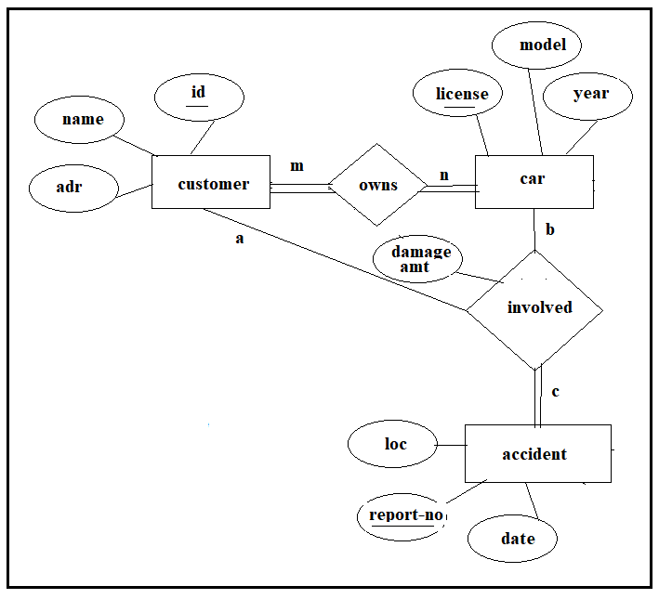

**In a university, students enroll in courses. A student must be assigned to at least one or more courses. Each course is taught by a single faculty. To maintain instruction quality, a faculty can deliver only one course. A student is identified by roll, name and age. Every course has its own id & name. A faculty is associated with emp_id, name & email.**

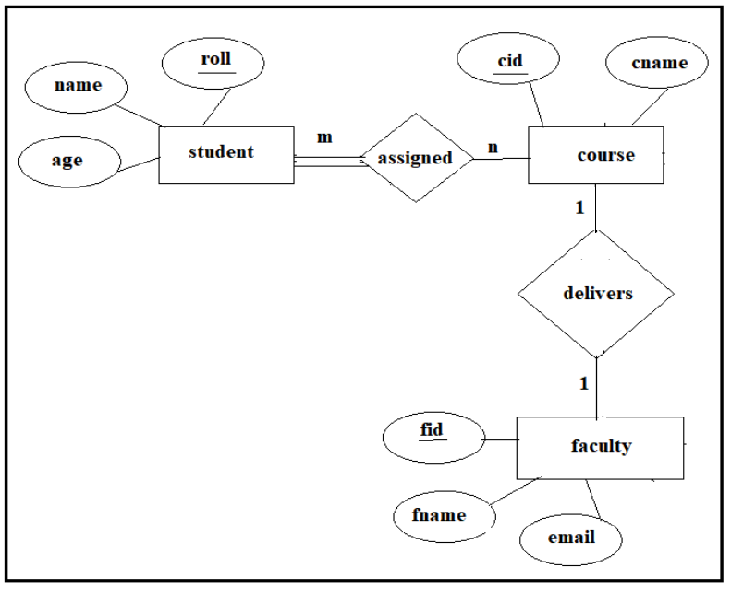

**A university registrar’s office maintains different kinds of college related data where all students should be enrolled in at least one course among many courses available for selection. Students can choose any course based on their preference. An instructor if found suitable can teach more courses such that not a single course is left unassigned to any instructor and no instructor is idle after course allotment. A specific course provides its own offerings which defines its semester, year, time, section and room-no. A student is identified by roll, name and program of enrolment. Any course is defined by its id, credits and course name. Similarly the department, emp-id and name of employee are the attributes of an instructor of the university. Further, the enrollment of students in courses along with the grades awarded to all students must be appropriately modeled. Construct an E-R diagram for the registrar’s office. Document all assumptions that you make about the mapping constraints.**

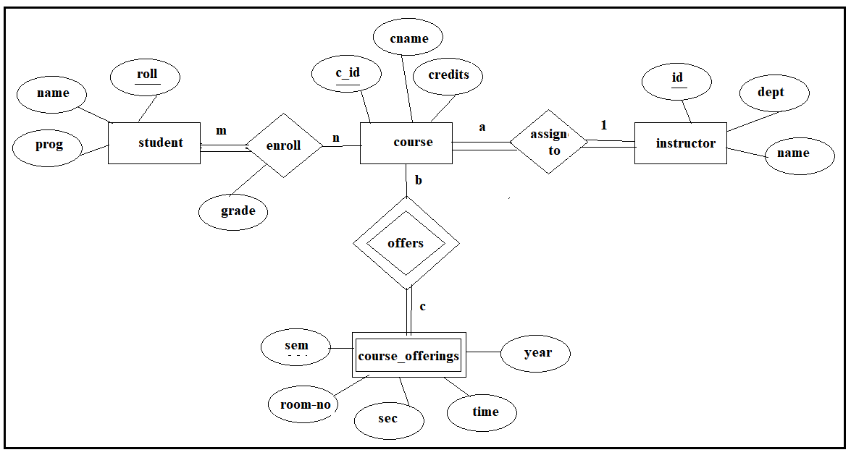

**UPS prides itself on having up-to-date information on the processing and current location of each shipped item. To do this, UPS relies on a company-wide information system. Shipped items are the heart of the UPS product tracking information system. Shipped items can be characterized by item number (unique), weight, dimensions, insurance amount, destination, and final delivery date. Shipped items are received into the UPS system at a single retail center. Retail centers are characterized by their type, uniqueID, and address. Shipped items make their way to their destination via one or more standard UPS transportation events (i.e., flights, truck deliveries). These transportation events are characterized by a unique scheduleNumber, a type (e.g, flight, truck), and a deliveryRoute.**

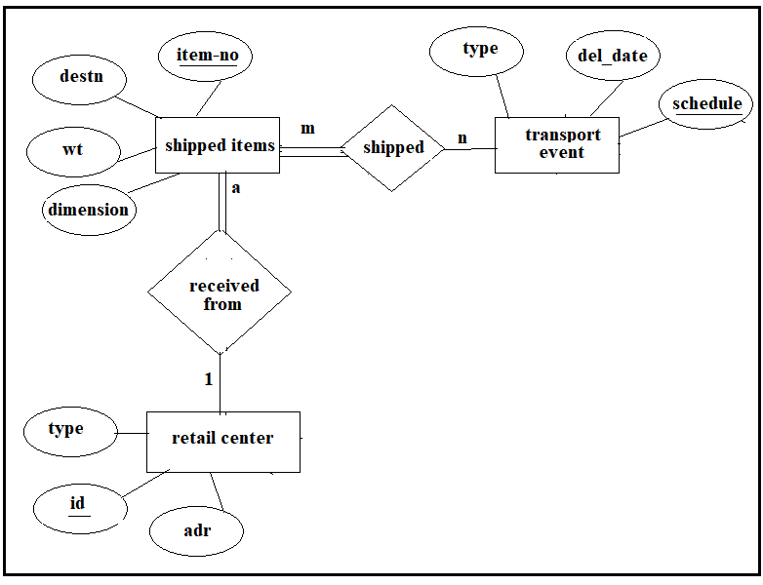

**A company has several depts identified by their dept_name. Each dept has a supervisor & at least one employee. All employees are allocated their emp_id. An employee must be assigned to at least one but possibly more depts. At least one employee is assigned to a project but an employee may be on vacation & not assigned to any project. Every project has its own code.**

